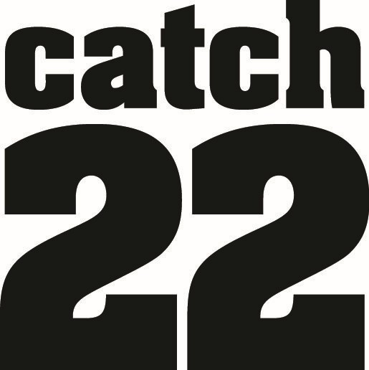
Merton Young Person’s Risk & Resilience Service
Referral Form
Substance Use/Smoking/Vaping/Exploitation

Young person’s details |  |  |  | Family details
Name: |  |  |  | Name of  Parent/carer:
Address: |  |  |  | Address:  (If different from young person’s)
Postcode: |  |  |  | Contact number:
Contact number:
Mobile Number:
Best way to contact client: |  | Best time: |  | Please describe the relationship the young person has with their parents/carers and/or people they live with:
Date of Birth: |  | Male ◻  Female ◻
Ethnic Origin:

GP Details  Name and practice: |  |  |  | Clients Learning Difficulties/ Disabilities:
Is the young person aware of referral to Catch 22? YES / NO
Has young person consented to the referral? (Consent must be obtained) YES / NO
Is the Parent / Carer aware of the referral? YES / NO
I consent to Catch22 processing my data in response to this form, in line with its Privacy Notice.

Referrer details
Name | Team | Agency | Contact Number | Date Completed
Other key professionals |  |  |  | Aware of referral
Name |  | Agency | Contact Number | Aware of referral
 |  |  |  | YES / NO
 |  |  |  | YES / NO
 |  |  |  | YES / NO
Is the child on a CP Plan? |  | YES / NO | Is the child on a CIN Plan? | YES / NO
Is the child LAC/Leaving Care? |  | YES / NO | Is the child placed here from another LA? | YES / NO

FOR SMU REFERRALS ONLY
Drug/Alcohol Use – Please tick which substance is the main problem substance and then 2nd and 3rd. Please also state the frequency, amount used and age at first use.
Substance | Main Substance |  |  |  | Second Substance | Third Substance |  | Frequency |  |  | Amount used | Age at first use
Tobacco/nicotine | □ |  |  |  | □ | □ |  | ………….. |  |  | ………….. | …………..
Vaping | □ |  |  |  | □ | □ |  | ………….. |  |  | ………….. | …………..
Cannabis | □ |  |  |  | □ | □ |  | ………….. |  |  | ………….. | …………..
Alcohol | □ |  |  |  | □ | □ |  | ………….. |  |  | ………….. | …………..
Ecstasy (MDMA) | □ |  |  |  | □ | □ |  | ………….. |  |  | ………….. | …………..
Ketamine | □ |  |  |  | □ | □ |  | ………….. |  |  | ………….. | …………..
LSD | □ |  |  |  | □ | □ |  | ………….. |  |  | ………….. | …………..
GHB | □ |  |  |  | □ | □ |  | ………….. |  |  | ………….. | …………..
Cocaine | □ |  |  |  | □ | □ |  | ………….. |  |  | ………….. | …………..
Crack Cocaine | □ |  |  |  | □ | □ |  | ………….. |  |  | ………….. | …………..
Heroin | □ |  |  |  | □ | □ |  | ………….. |  |  | ………….. | …………..
Opiates (illicit) | □ |  |  |  | □ | □ |  | ………….. |  |  | ………….. | …………..
Solvents (Glue/gas/aerosol) | □ |  |  |  | □ | □ |  | ………….. |  |  | ………….. | …………..
Benzodiazepine (e.g. Valium, Xanax) | □ |  |  |  | □ | □ |  | ………….. |  |  | ………….. | …………..
Psychoactive Substances | □ |  |  |  | □ | □ |  | ………….. |  |  | ………….. | …………..
Other/s- Specify | □ |  |  |  | □ | □ |  | ………….. |  |  | ………….. | …………..
Intoxication – Has the young person ever experienced any of the following in relation to their drug use?
Loss of consciousness □ |  |  |  |  |  |  | Hospitalisation (please provide details)
Loss of memory □
Aggression □
Injecting – Please tick injecting status and provide details below
Not injecting □ |  |  | Currently Injecting □ |  |  |  |  | Previously injected □
Details:–

Circumstances – the following are likely to contribute to the young person’s substance misuse increasing
Not attending school □ |  |  |  |  |  |  | Mental health problems □
History of trauma, bereavement, or loss □ |  |  |  |  |  |  | Involved in criminal activity □
Homelessness / unstable accommodation □ |  |  |  |  |  |  | Pregnant □
Difficult relationship with parents and/or an experience of living in care □ |  |  |  |  |  |  | Partner / close friends / family members who use drugs/alcohol □

Health issues - Please summarise any physical / mental health problems including any prescribed medication.
Risk – Please advise us of any significant risks that we should be aware of
Substance Misuse Related  Overdose, health problems exacerbated by substance misuse, injecting, sharing equipment |  |  |  | Mental Health  Mental health diagnosis or issues, ever detained under mental health act |  |  |  |  |  | At Risk of harm  Use of weapons, serious harm from/ to another person, convictions for sexual offences, expressed intent to harm, Multi Agency Public Protection, violence/ threats from another person (dealers)
Suicidal intent  Suicidal intent or ideation, self harming behaviour, suicide plan |  |  |  | Child Safeguarding issues  Looked After Child, Child Protection Plan, Child In Need. |  |  |  |  |  | Risk to staff  Any risk or reason staff should not see the client on their own
Other:

Please provide any additional information which will assist the service to manage the needs and any risks associated with this client:

FOR EXPLOITATION REFERRALS ONLY

Have you had a consultation with C22 and the Contextual Safeguarding Team? YES / NO
The Contextual Safeguarding Screening Tool has been completed and is attached? YES / NO
The YP and their parent/carer has consented? (Consent must be obtained) YES / NO
What is the contextual harm screening score?
EARLY HELP (Emerging) | 10 – 32
TARGETED  (Moderate) | 33 – 64
SPECIALIST (Significant) | 65 – 100+

Please provide any additional information which will assist the service to manage the needs and any risks associated with this client e.g. Background of concerns/reason for referral, your aims and objectives for the treatment provided by C22, preferred male or female worker, any learning disabilities to be aware of, etc.

Tel: 020 3701 8641 |  | secure.referrals@catch22msm.cjsm.net |  |  |  |  |  |  | Email: MSM@catch-22.org.uk
Catch 22 Merton YP Risk & Resilience Service, Civic Centre, Morden Library, London Road, Morden, SM4 5DX

